



**AURA WATCHES**

**zzayesha, HADIA, SADIA**

**(e-PROJECt)**

**AURA WATCHES**

**BY**

**SHARIQ NAJAM,**

**BILAL AHMED,**

**HAFIZ ABDULLAH**





**CERTIFICATE OF COMPLETION**

This is to certify that this project entitled “AURA WATCHES” submitted in partial fulfillment of the E-Project completed by

**SHARIQ NAJAM,**

**BILAL AHMED,**

**HAFIZ ABDULLAH**

Signature: ________________________



INDEX



1. *Introduction*
2. *Acknowledgement*
3. *About E-project*
4. *Project Objective*
5. *Problem Statement*
6. *Project Requirement*
7. *Screen Shots*
8. *Hardware And Software*

*9. Thank You*



# introduction:

*The thirst for learning, upgrading technical skills and applying the concepts in real*

*life environment at a fast pace is what the industry demands from IT professionals*

*today. However busy work schedules, far-flung locations, unavailability of convenient*

*time-slots pose as major barriers when it comes to applying the concepts into*

*realism. And hence the need to look out for alternative means of implementation in*

*the form of laddered approach.*

*The above truly pose as constraints especially for our students too! With their busy*

*schedules, it is indeed difficult for our students to keep up with the genuine and*

*constant need for integrated application which can be seen live especially so in the*

*field of IT education where technology can change on the spur of a moment. Well,*

*technology does come to our rescue at such times!!*

*Keeping the above in mind and in tune with our constant endeavour to use*

*Technology in our training model, we at Aptech have thought of revolutionizing the*

*way our students learn and implement the concepts using tools themselves by*

*providing a live and synchronous eProject learning environment!*

# 



**aknowledgement**

*We are very thankful to Dear Almighty ALLAH by his grace I was able to complete this task.*

*I would like to acknowledge all who helped and guide me all the way to finish this task.*

*I am really grateful because I managed to complete my E-project within the time given by our teacher* ***MISS ARSHIA ABDUL MUNAF****. This assignment cannot be completed without the effort.*

*I also sincerely thank our teacher* ***MISS ARSHIA ABDUL MUNAF*** *for the guidance and encouragement in finishing this project and also for teaching us in this course.*

*Last but not the least, I would like to express my gratitude to our friends and respondents for the support and willingness directly or indirectly to spend some times with us to fill in the questionnaires.*

**So what is this eproject?**

**So what is this eProject?**

*eProject is a step-by-step learning environment that closely simulates the classroom*

*and Lab based learning environment into actual implementation. It is a project*

*implementation at your fingertips!! An electronic, live juncture on the machine that*

*allows you to*

*o Practice step by step i.e. laddered approach.*

*o Build a larger more robust application.*

*o Usage of certain utilities in applications designed by user.*

*o Single program to unified code leading to a complete application.*



*o Learn implementation of concepts in a phased manner.*

*o Enhance skills and add value.*

*o Work on real life projects.*

*o Give a real life scenario and help to create applications more complicated and*

*useful.*

*o Mentoring through email support.*

*The students at the centre are expected to complete this eProject and send complete*

*project along with the documentation to eProjects Team*

*Looking forward to a positive response from your end!!*

# Objectives of the project

*Objectives of the project*

*The Objective of this program is to give a sample project to work on real life*

*projects. These applications help you build a larger more robust application.*

*The objective is not to teach you JavaScript/Dreamweaver but to provide you with a*

*real life scenario and help you create basic applications using the tools.*

*You can revise the chapters before you start with the project.*

*This project is meant for students who have completed the module of*

*Dreamweaver. These programs should be done in the Lab sessions with assistance*

*of the faculty if required.*

*It is very essential that a student has a clear understanding of the subject. Students*



*should go through the project and solve the assignments as per requirements given.*

*Kindly get back to eProjects Team in case of any doubts regarding the application or its objectives.*

**PROBLEM statement**

***Problem Statement***

Aura watches is into business of manufacturing and selling watches. They have been

advertising about their clocks and watches through newspapers, pamphlets,

television. Now with changing times, they have decided to go online as customers

today use Internet extensively. They have planned for a website with complete

details about their watches and clocks.

**Requirement Specification:**

The Web site is to be created based on the following requirements.

1) The Home Page should have suitable logo, and decent colour combination.

2) The site should display a menu which will contain the options as Products,

Technology, Store Locator, Support etc.

3) Various pages having information about different types of watches and clocks,

Technology used in the watches etc.

4) The information should be categorized according to different Product Line-up

e.g. “SPORTZ”, “PREMIER” etc.

5) When a user selects any product line-up, complete list of watches for that

product line-up will be displayed.

6) Details of the watches should be displayed on the Web Page along with the

title and it should be stored in Individual Word documents which can be

downloaded or viewed by the User who wishes to see the same.

7) Price List for all watches should be available for download.

8) There should be a “Contact Us” page which will have the Address of the

Stores selling watches and the mail address which when clicked will invoke

the local mail client from where they can send an email.



**HARDWARE / SOFTWARE REQUIREMENTS**

***Hardware/ Software Requirements***

**Hardware**

* A minimum computer system that will help you access all the tools in the courses is a Pentium 166 or better
* 64 Megabytes of RAM or better

**Software**

* Notepad/HTML editor/CoffeeCup
* Angular / Angular JS / React / BootStrap
* Dreamweaver / Figma
* MS IE / Chrome / FireFox / Netscape /MS Edge



# SCREEN SHOTs

****HOME PAGE**



# *HOME PAGE CODE*

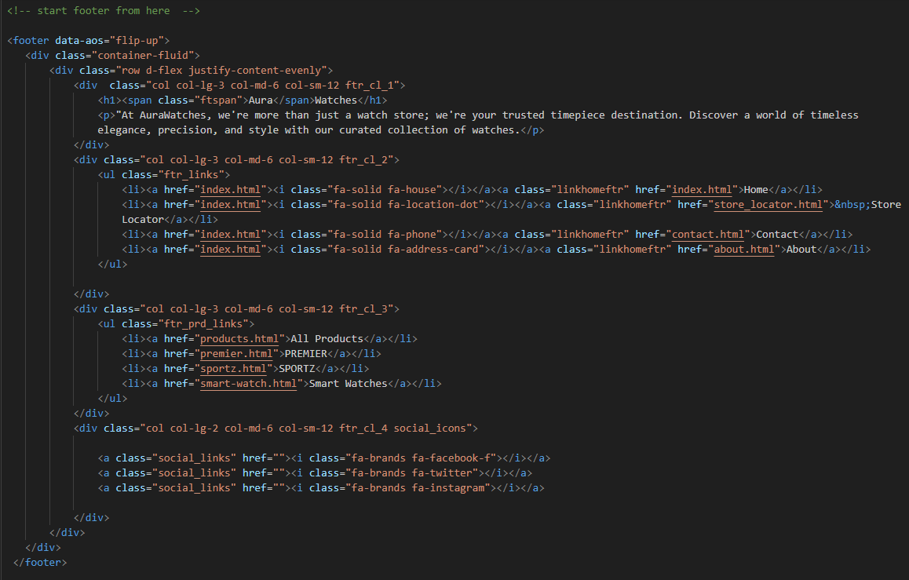



*NAVIGATION BAR*

*NAVIGATION BAR SOURCE CODE*

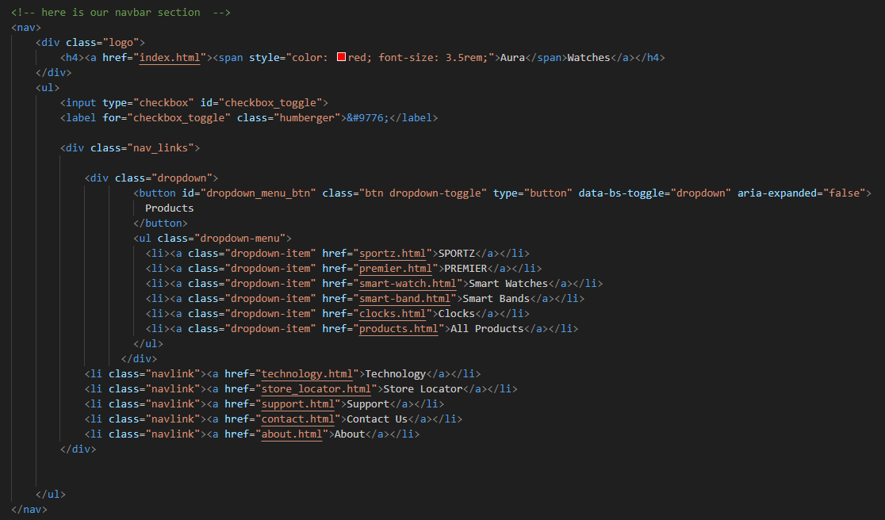



**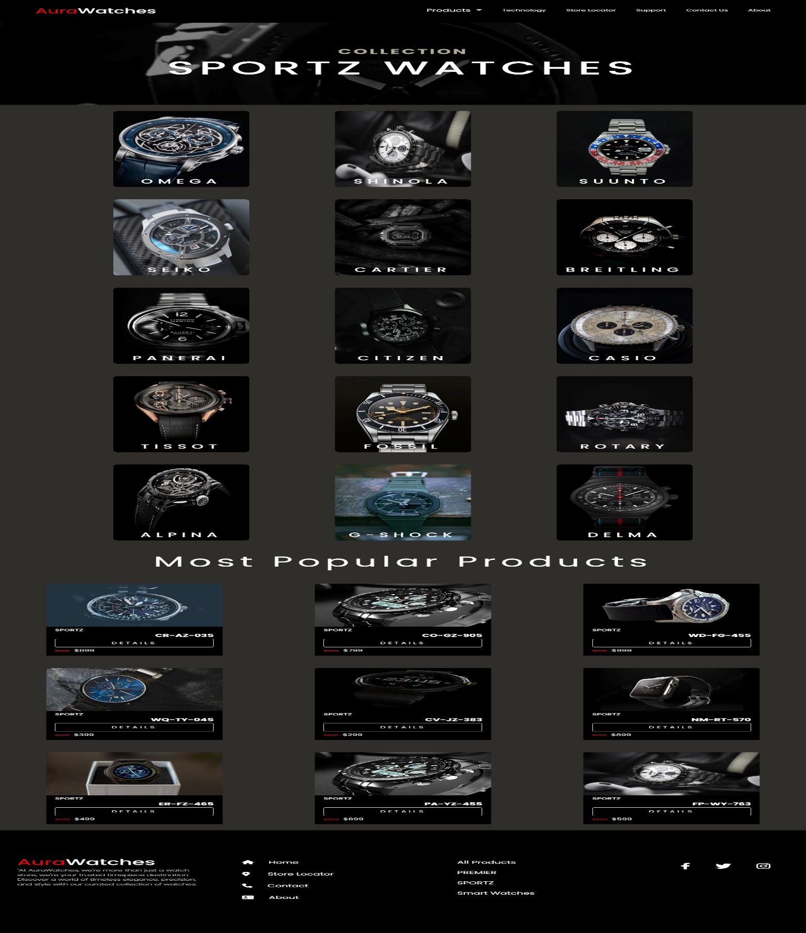***SPORTZ PAGE*



*SPORTZ PAGE SOURCE CODE*

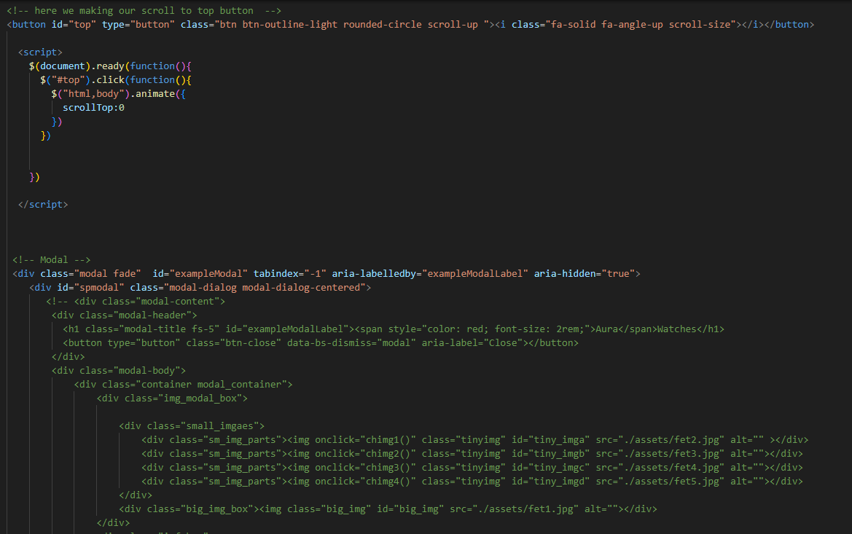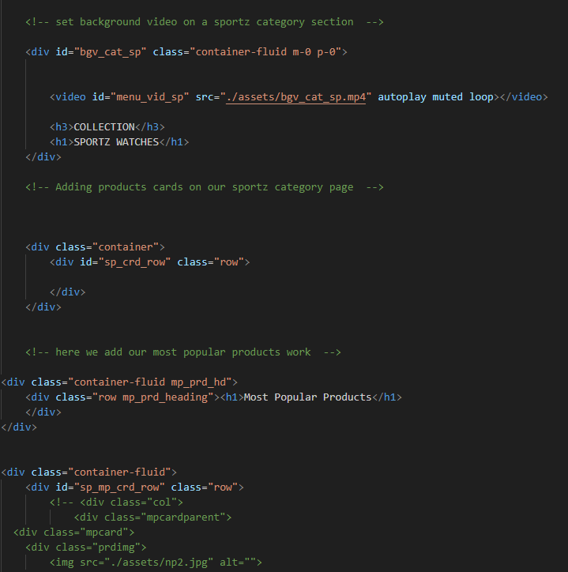



*PREMIER PAGE*

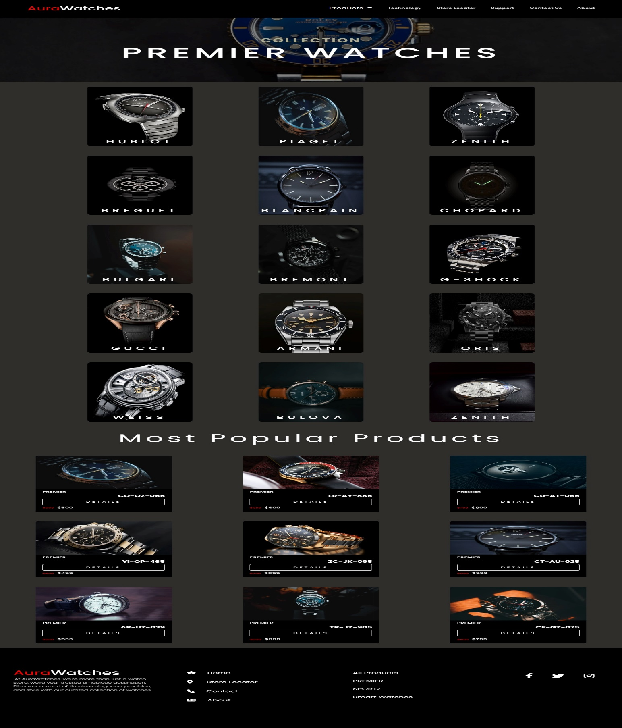



**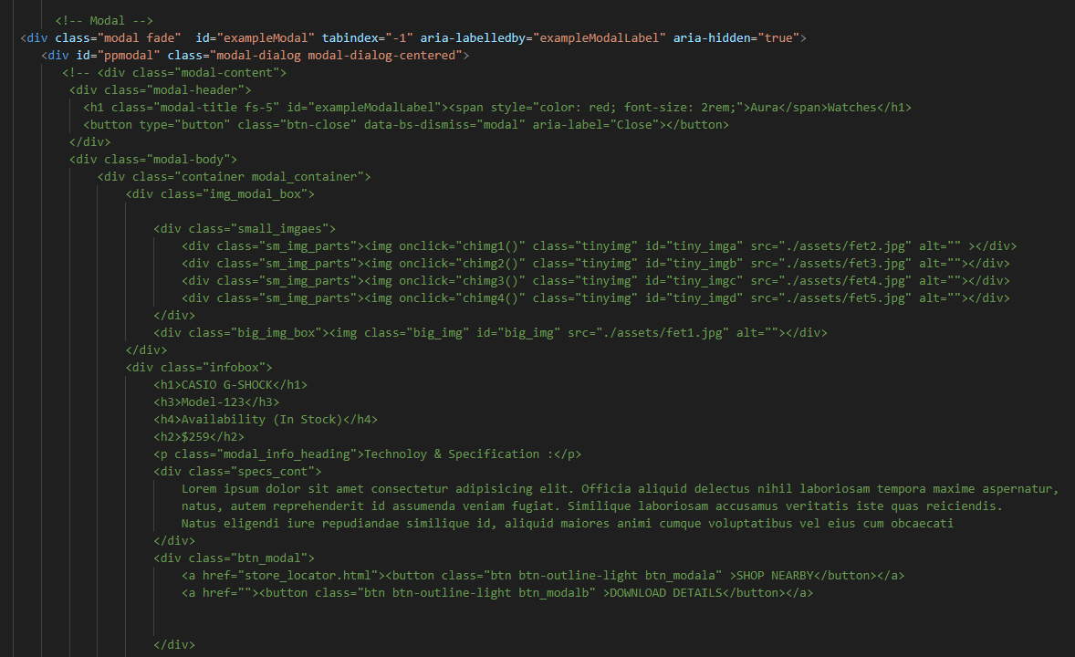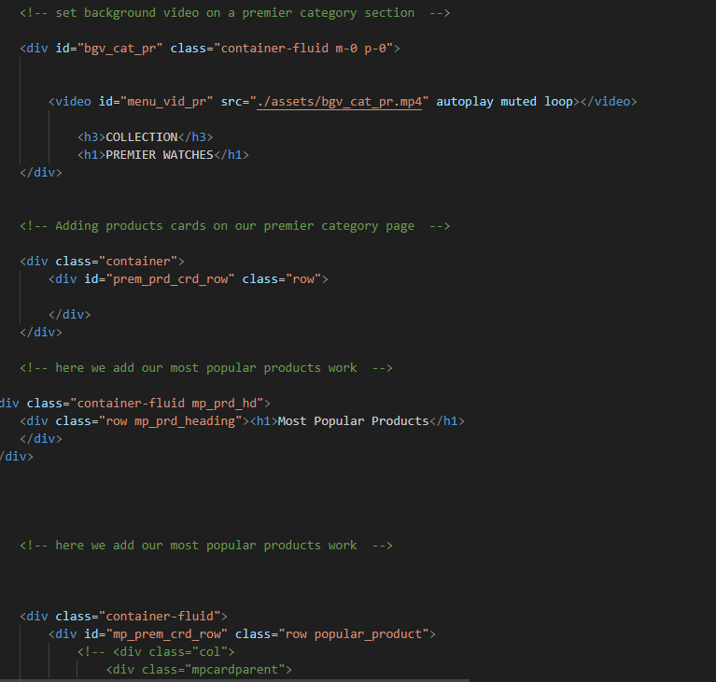***PREMIER PAGE SOURCE CODE*



**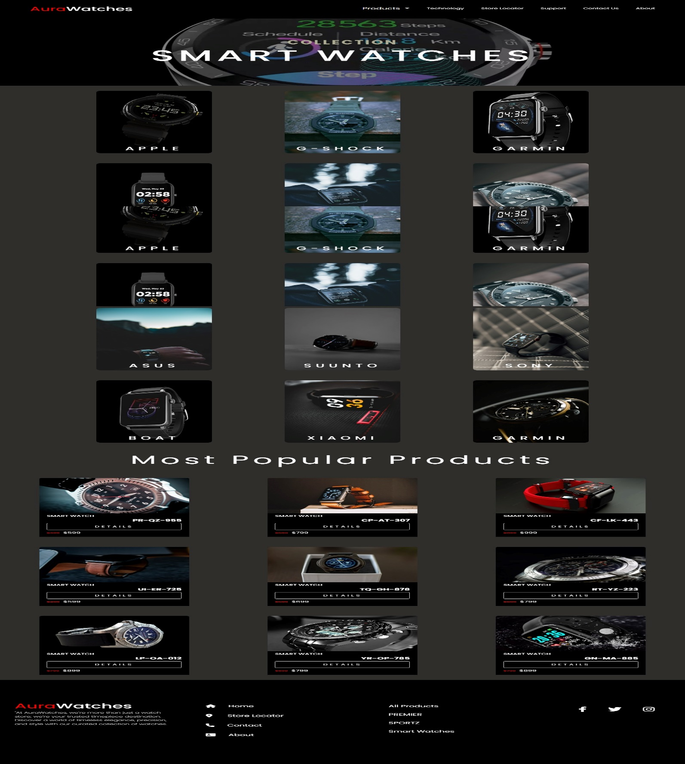***SMARTWATCH PAGE*



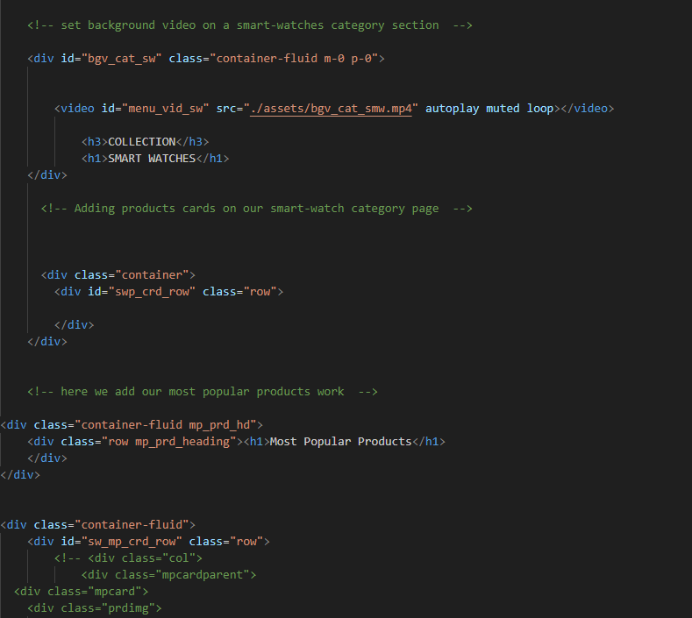



*SMARTWATCH PAGE SOURCE CODE*

***THE FOOTER WITH SUBJECT* INFORMATION**

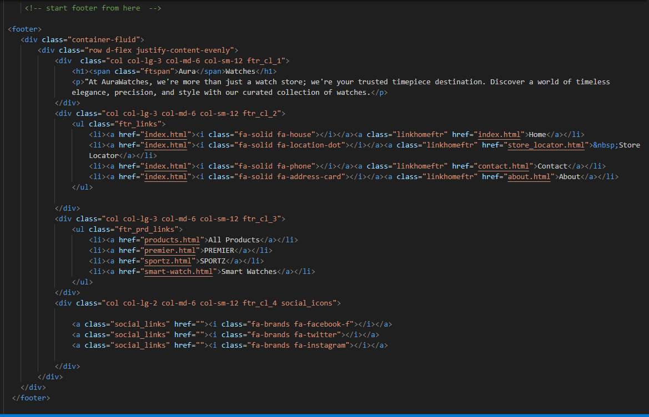***FOOTER SOURCE*** *CODE*



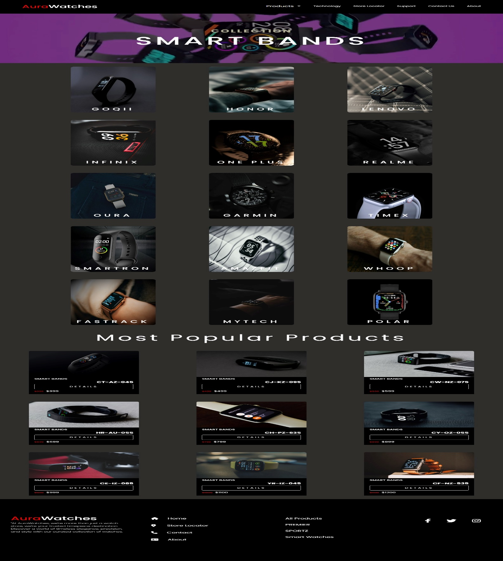**SMARTBAND PAGE**



**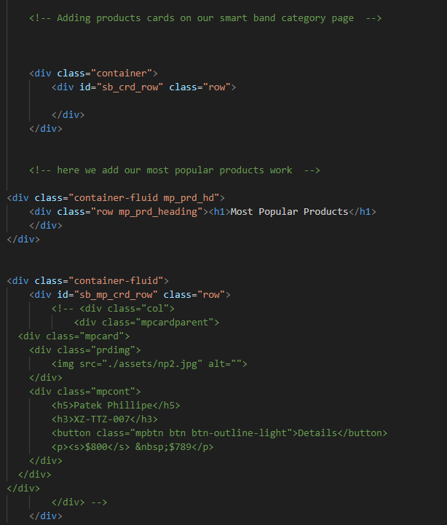***SMARTBAND SOURCE CODE*



***CLOCK PAGE***

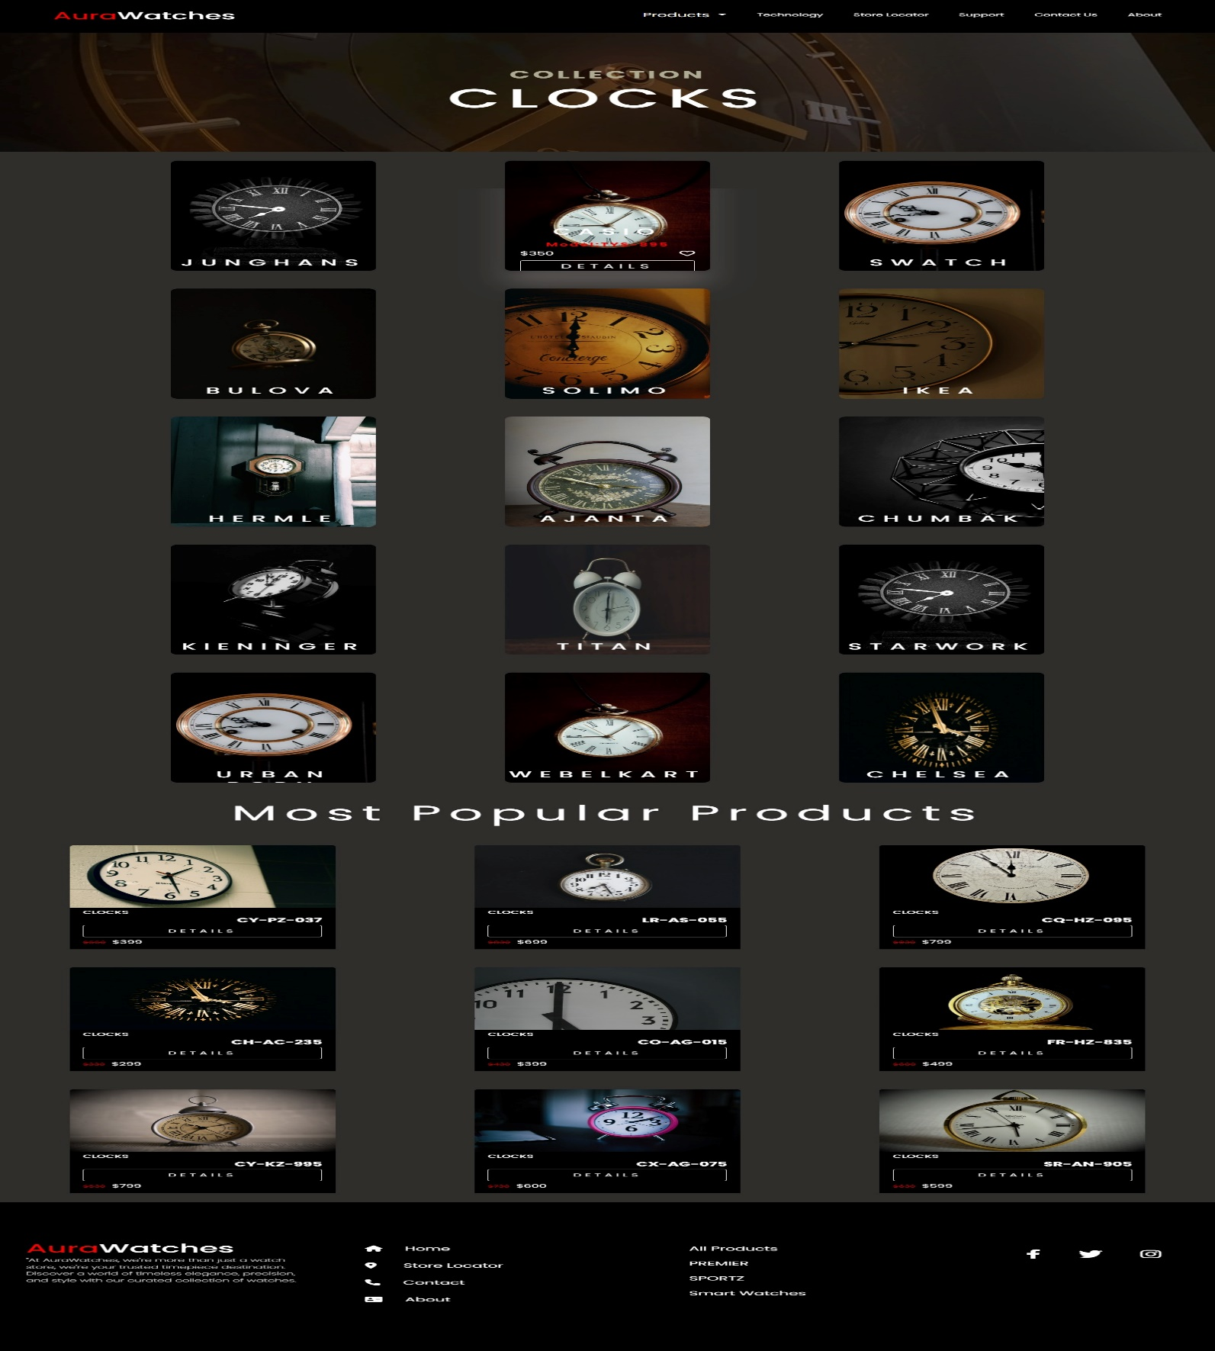



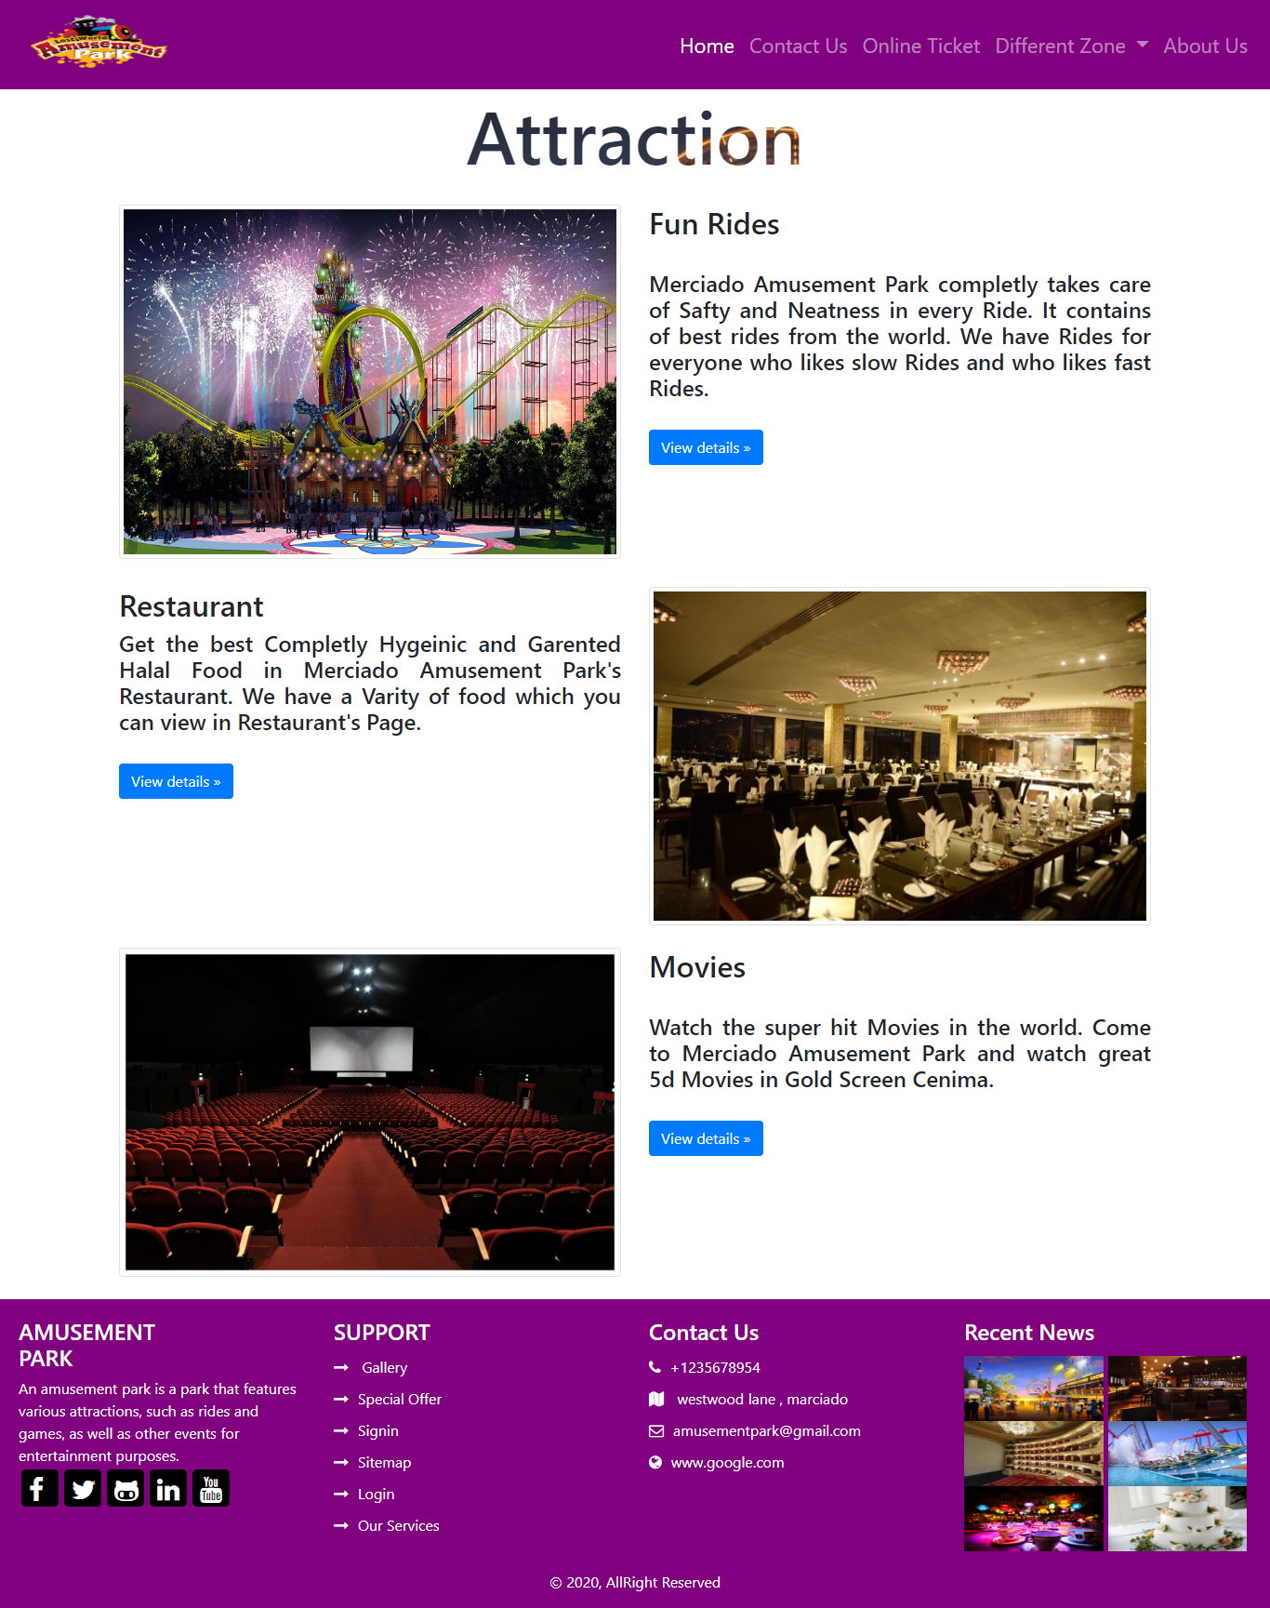***ATTARACTION PAGE***



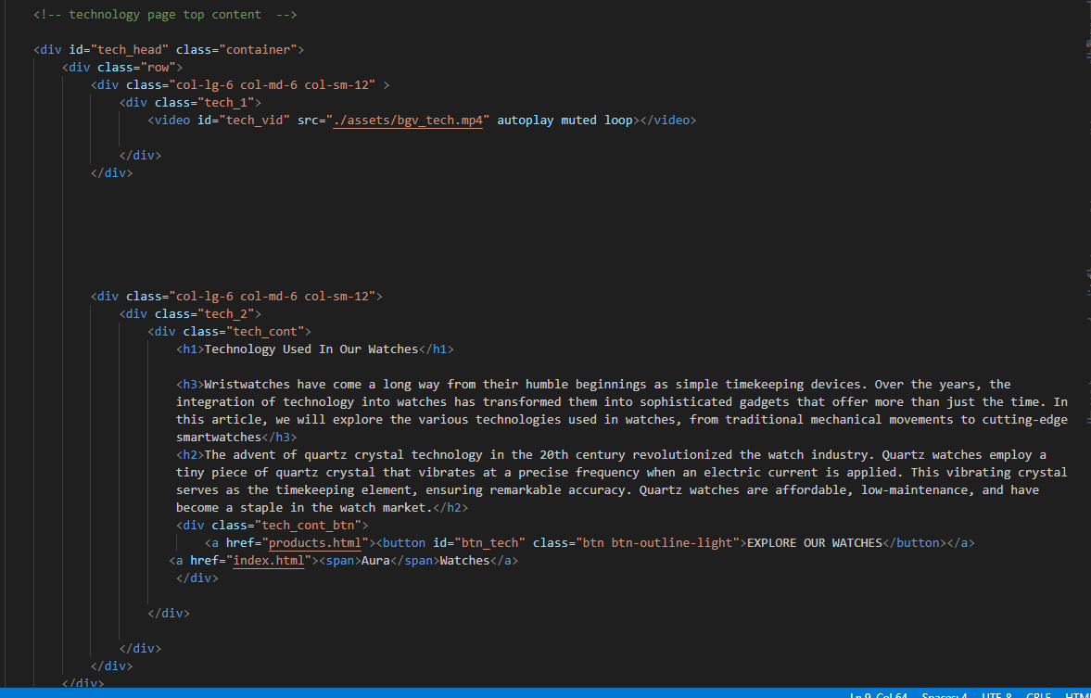***TECHNOLOGY SOURCE CODE***



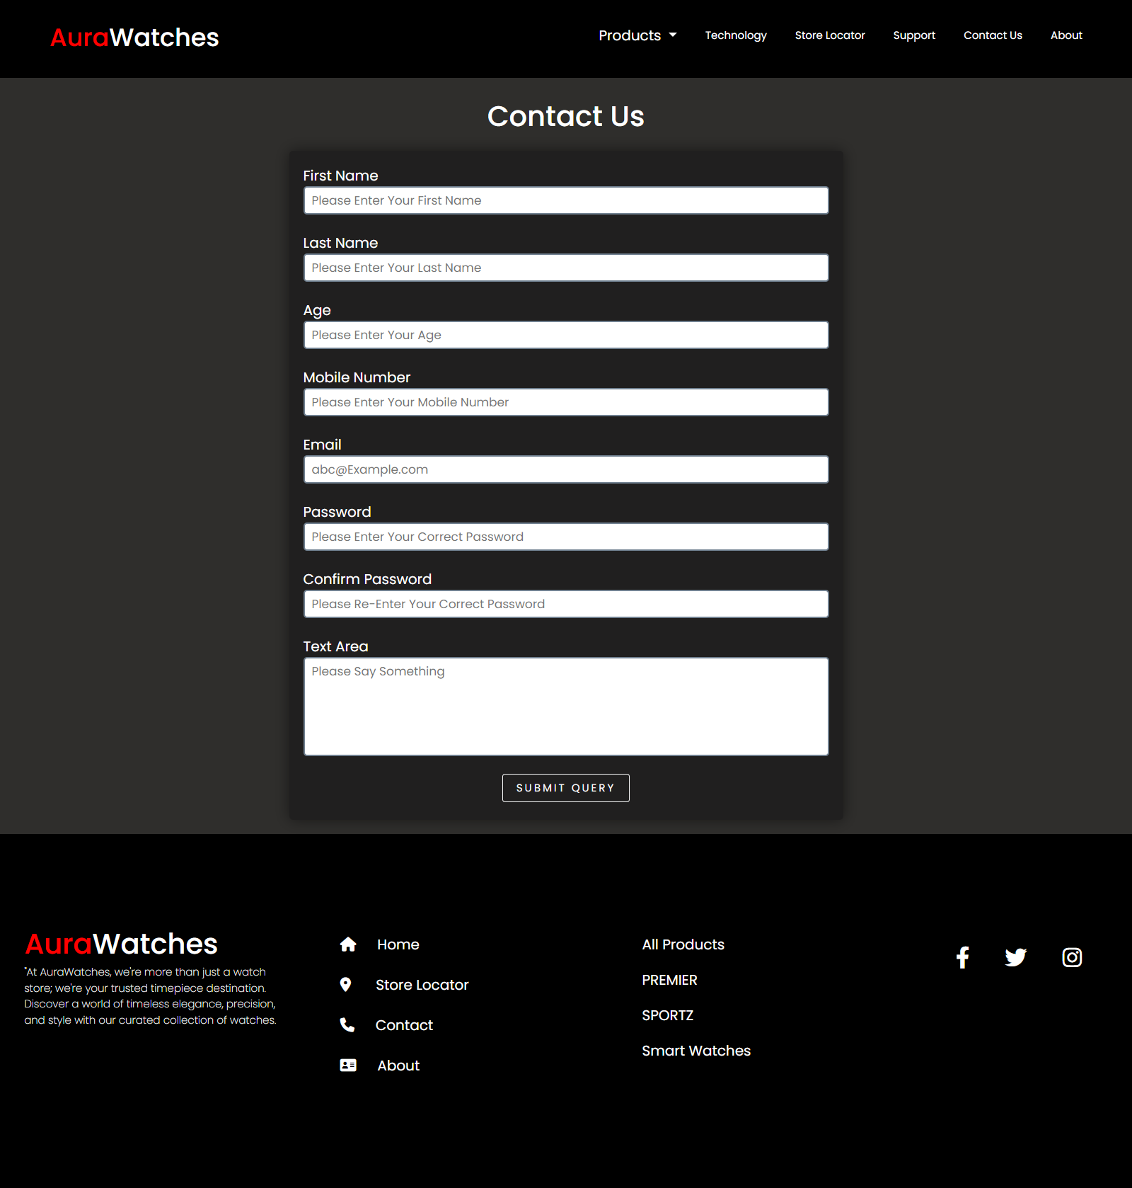***CONTACT US PAGE***



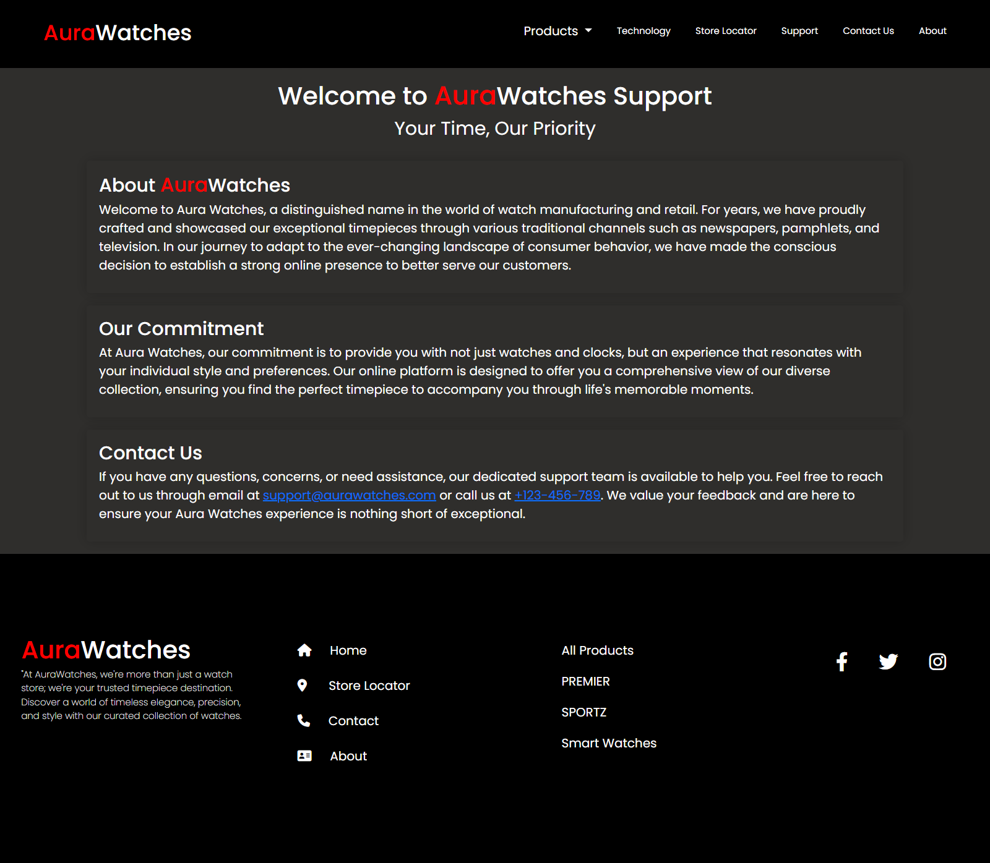***OUR SUPPORT PAGE***



***ABOUT US PAGE***

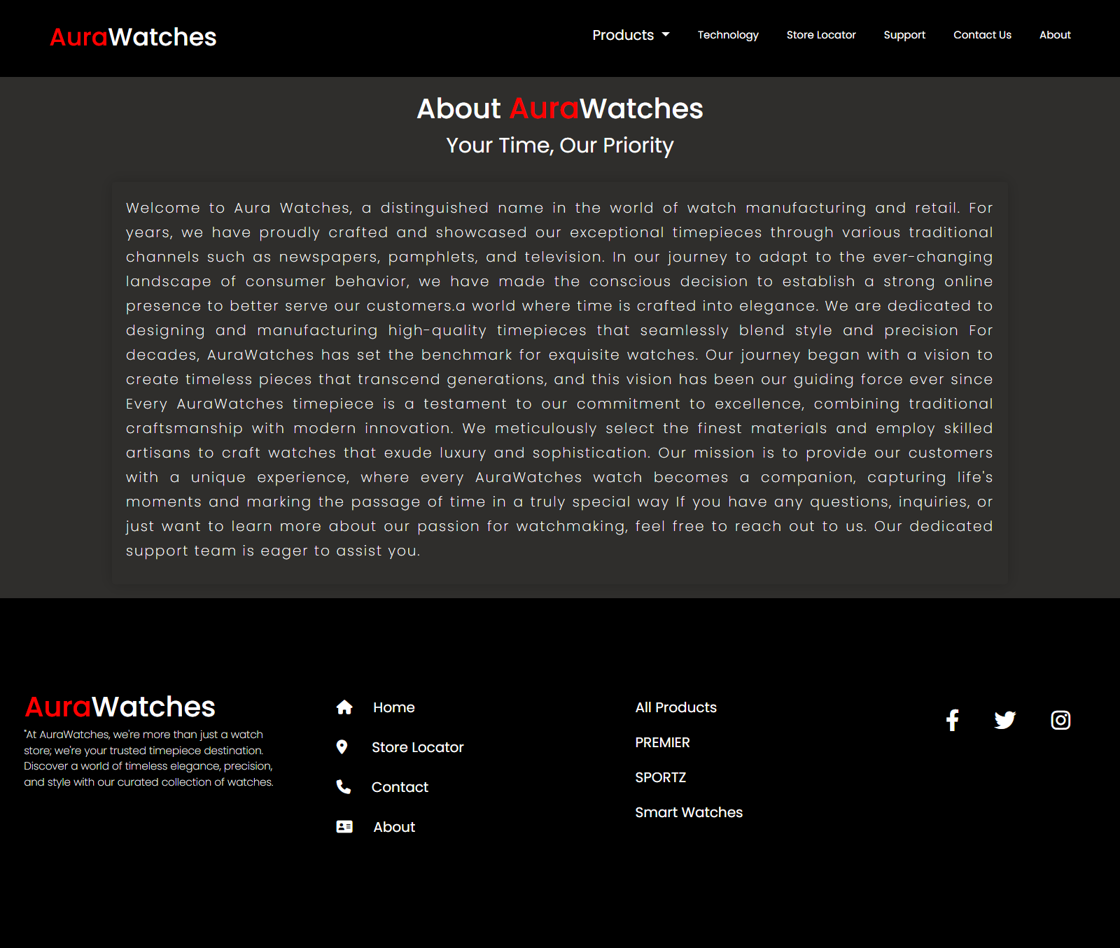



***E-PROJECT TASK SHEET***

|  |  |  |
| --- | --- | --- |
| **SHARIQ NAJAM** | | **PROGRESS** |
| ☐ | *Made a Prototype of a website* | 100% |
| ☐ | *Made a Structure of the website with HTML* | 100% |
| ☐ | *Put the Validations to the form using HTML Patterns* | 100% |
| ☐ | *Find and Fixed the Bugs* | 100% |
| ☐ | *Lead the project* | 100% |
| ☐ | *Code the website* | 70% |
| ☐ | *Graphic Designing work* | 100% |
| ☐ | *Scripting* | 100% |
| ☐ | *Documentation* | 100% |
|  |  |  |
| ***HAFIZ ABDULLAH & BILAL KHAN*** | | **PROGRESS** |
| ☐ | *Code the website* | 30% |
| ☐ | *Find the Products that relates to our topic to add it on to the e-project* | 100% |
| ☐ | *Find the different images of our topic.* | 100% |
|  |  |  |



